
Product Donation Drive Guide

- Create Wish List
You can use Target, Amazon, and even Walmart.
Maeves Pads (www.maevespads.com) is another online site you can use and local to Dallas.

- QR Code
Create a QR Code for your wish list. Sometimes it is a good idea to provide two options. Amazon and then Target or Walmart.
Free QR Code Site:
You can customize the QR code.
Here is one I created for an example. It will actually take you to She Supply.
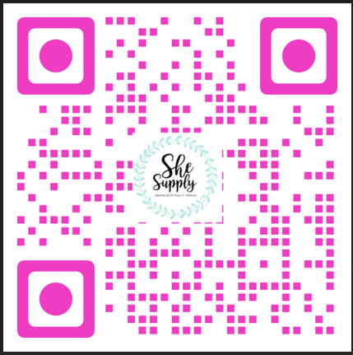
Free QR Code Generator | Create Your Free QR Codes
https://www.free-qr-code-generator.com/

- Create a social media document
Canva is a site you can create a flyer and paste in the QR code(s) canva.com
You can also just use a Word document.

- Draft an Email
If you plan to send out an email blast to introduce your product drive below are some key points you can add in your email.

- Links to She Supply website and social media (you find us on Instagram, Facebook, and TikTok)
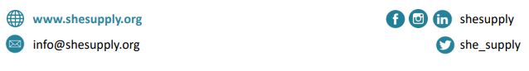
- Facts about Period Poverty:
- Women and girls in poverty often struggle to secure the basics like food, shelter and clothing, but also have another uniquely feminine necessity: menstrual hygiene (or, period) supplies.
- 1 in 4 North Texas women and girls continue to struggle monthly to afford or access hygiene/period products.
- 1 in 3 low-income North Texas women miss work and girls miss school monthly because they chronically do not have hygiene/period products.
- Who is She Supply and what do they do:
- Mission: To fight the effects of poverty through service and friendship to women of all ages and to change the trajectory of their lives. Provide a sense of dignity and cleanliness to women in less
fortunate circumstances
- We are unapologetically female with a focus on empowering women by providing the most basic female necessities to women in the North Texas area.
- She Supply fills this need so that women and girls can maintain proper hygiene and dignity, attend work or school, and other activities and opportunities otherwise not possible without proper products.

- Social Media
Post your drive on all social media platforms and ask others to also repost
- Post the flyer
- Post the QR code
- Post a video
- Donation Drive Party Ideas & Collaborations
- Party:
- Menopause Party
- Girls/ Ladies Night in Party
- Theme Party
- Game Night
- Neighborhood Block Party
- Collaboration
- Organization or Club you are affiliated with in your area
- Any ERG at your place of work
- Religious Group

Things to remember!!!!
- Create the Hype around your drive!
- Post on a regular basis!
- To keep track of your month-long drive, remember to update your progress each week. For instance, if your target is to gather 100 boxes of tampons and pads, consider making a flow chart to visually represent your progress towards that goal.
Here is a free link you can use: Free Fundraising Thermometer Template & Creator | CauseVox

For more ideas visit our site: https://shesupply.org/wp-content/uploads/2020/01/She-Supply-DIY-Donation-Drive-Planner.pdf

